**Adding custom private IP to EC2 instance:**

* While creating EC2 instance, if we select VPC other than default one. We get an option downside for network interface as below.

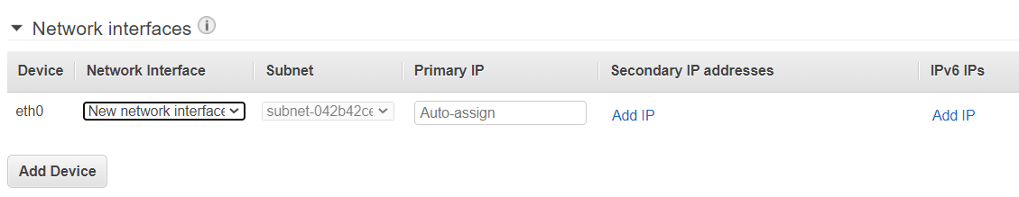

* We can select “new network interface” option there and assign the IP whatever we want. We can see the network interfaces in drop down if we already have ENIs.
* We can also assign secondary IP if we want.
* This primary IP address we can’t change.

**Change security group to an instance:**

We can change in below path.

**Select instance 🡪 actions 🡪 network 🡪 change security group**